THE UNIVERSITY OF AZAD JAMMU & KASHMIR, MUZAFFARABAD
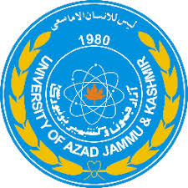

COURSE TITLE | OS
COURSE CODE | CS-2105
LAB TITLE | INTRO. TO OS
STUDENT NAME | HASEEB SHEIKH
STUDENT ROLL NUMBER | 2024-SE-31
INSTRUCTOR NAME | ENGR. SIDRA RAFIQUE
SUBMISSION DATE | OCT 24, 2025

DEPARTMENT OF SOFTWARE ENGINEERING
OS
Lab 1
System's Operating System
Processor Details
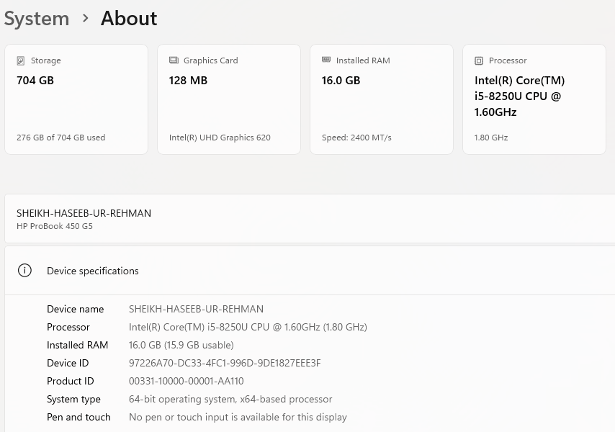
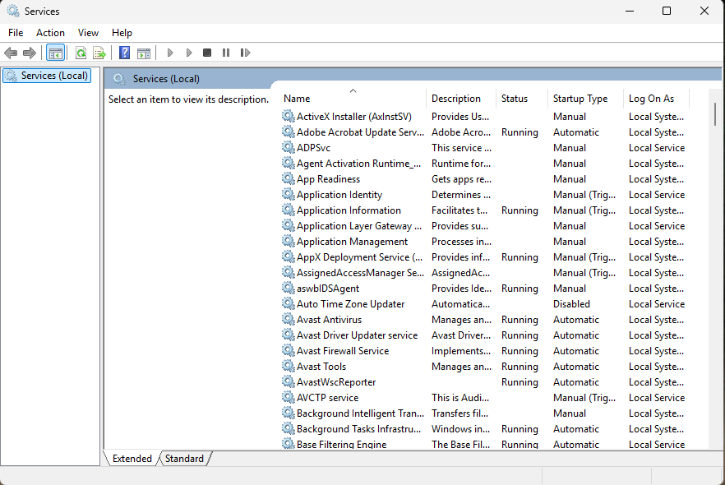
Operating System Services

- Windows Services are applications that typically start when the computer is booted and run quietly in the background until it is shut down.
Windows Task Manager
The Windows Task Manager is a powerful tool packed with useful information, from your system’s overall resource usage to detailed statistics about each process.
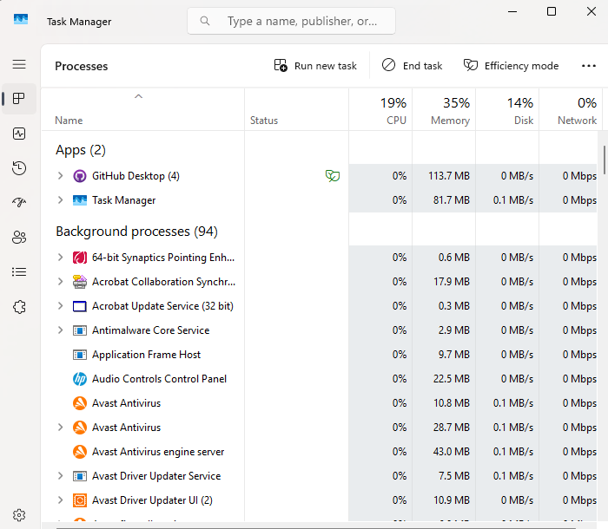
Processes show a list of running applications and background processes on your system along with CPU, memory, disk, network, GPU, and other resource usage information.

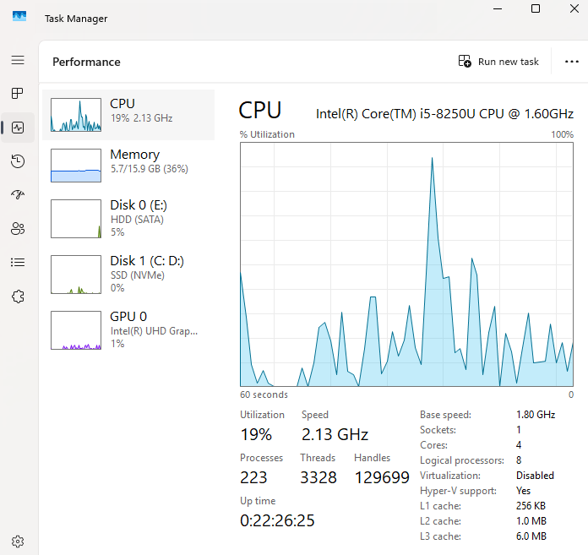
Performance: shows Real-time graphs showing total CPU, memory, disk, network, and GPU resource usage for your system.
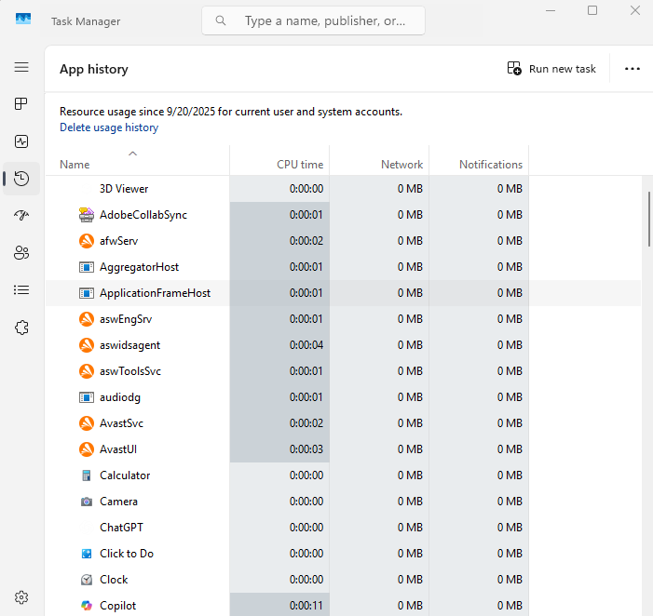
App History show Information about how much CPU and network resources apps have used for your current user account.

Users show the user accounts currently signed into your PC, how much resources they’re using, and what applications they’re running.
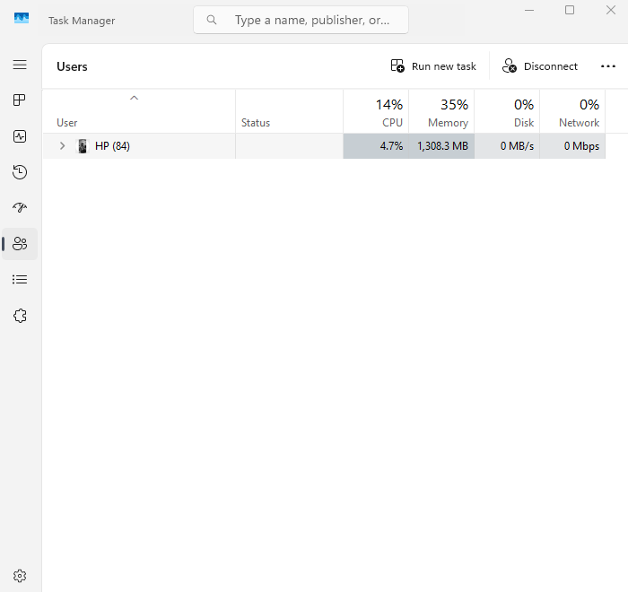
Details show more detailed information about the processes running on your system.
